Student-Teacher-Subject Code
AIM:
To write a Prolog program to create and query a database containing student, teacher, and subject code details.
ALGORITHMS:
- Start.
- Define facts for students, teachers, and subject codes.
- Create rules to associate students with teachers and subjects.
- Query the database.
- Display the matching student, teacher, and subject code details.
- Stop.
CODE:
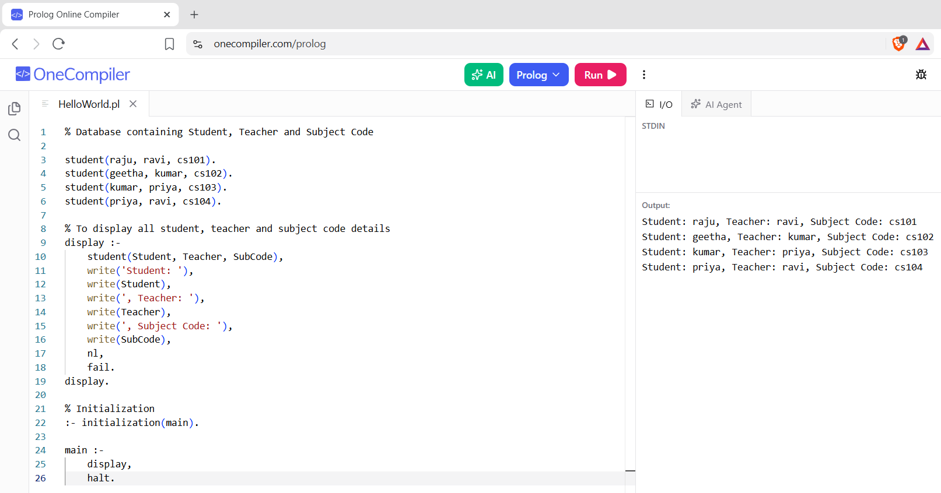
RESULTS:
The student, teacher, and subject code details are retrieved and displayed successfully.

